Will Schools be the next source of COVID outbreaks?
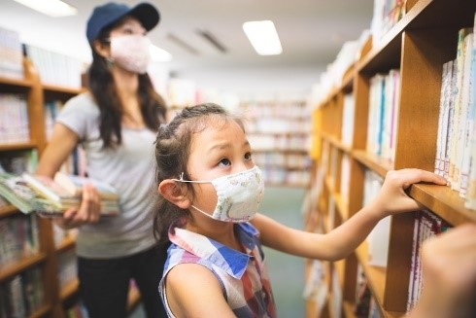

You may have a COVID-19 prevention strategy for your school(s) that includes temperature taking and self reporting of symptoms. Your teachers and staff are vaccinated. Kids are eager to return to full-time in person learning. You are ready to start a “normal” school year and put this whole pandemic behind you. However, the question that continues to linger…is this enough to protect your school(s) from a COVID-19 outbreak?

About 4 million kids under the age of 12 have tested positive for COVID. They represent nearly 14 percent of all new cases. [1]

Based on a recent study conducted in the UK, young people are starting to test positive for the coronavirus at five times the rate of older people [2]. As Governor J. B. Pritzker of Illinois noted when interviewed on this topic, “What I'm concerned about is that we don't yet have a vaccine for kids under 12 years old, and the Delta variant seems to have been predominant among people who are unvaccinated.” [3]

It takes four or more days from the date of infection to first sign of symptoms, which means those individuals can be on school grounds for almost a week unknowingly spreading the disease and can be even longer if they aren’t showing symptoms. Given this, researchers are recommending steps be taken to limit the spread of the virus as waiting until a student develops symptoms and tests positive is too slow a response, even though this was the method used in many jurisdictions to prevent COVID-19 transmission [4].
Regular monitoring of everyone in a school setting may be the only way to prevent outbreaks of COVID-19 in schools, per a study published in the Journal PLOS Computational Biology [5]. Proactive and comprehensive testing will help keep school districts ahead of the game by identifying those who are infected and may be asymptomatic, but are still positive for COVID-19, therefore continuing to spread to other individuals. Testing in schools is supported by government funds to help limit costs for school, is less invasive and the most effective way to monitor the prevalence of COVID-19.
Comprehensive K-12 coronavirus testing can be quickly implemented in schools and supported by government funds. With pooled sampling to keep costs more efficient, swabbing done quickly by students themselves, and prepaid return shipping to the testing facility, this program is designed to make in-school coronavirus testing an easy reality for students, educators and parents alike. To learn more about how to implement a coronavirus testing program, click here.
*************************************************************************************
Sources:
[1] https://www.thedenverchannel.com/news/national/covid-19-testing-still-critical-for-students-too-young-to-be-vaccinated
[2] https://www.cidrap.umn.edu/news-perspective/2021/06/youth-delta-variant-behind-uk-covid-surge
[3] https://www.nbcchicago.com/news/coronavirus/what-pritzker-says-concerns-him-about-the-covid-delta-variant/2534956/
[4] https://www.healthline.com/health-news/regular-testing-may-be-the-best-way-to-prevent-covid-19-outbreaks-at-schools
[5] https://journals.plos.org/ploscompbiol/article?id=10.1371/journal.pcbi.1009120

